**Physical Education Lesson #4**

**Hi Everyone,**

**It is important that we stay active, so our bodies remain healthy and strong! This lesson will begin with our warm-up activity to get the blood flowing and to loosen up our muscles. Following our warm-up, there will be three different exercises that we would like everyone to try. Try your best. Remember some things may be more difficult than others, but practice makes perfect! And have fun with it, we miss you! -Mrs. Miller**

**Begin with warm-up:**

**If you can get outside that will be best. Make sure there is an adult with you, and you have your sneakers on! Get a drink if you need in between!**

**- Speed walk for 1 minute**

**- Jog for 1 minute**

**- Stop and stretch- reach to sky and touch your toes**

**- Skip for 1 minute**

**- Stop and do 10 arm circles front and 10 arm circles backwards**

**- Gallop for 1 minute**

**- Stop and do 10 jumping jacks**

SEE EXERCISE BELOW! HAVE FUN! 😊

**Kindergarten: Please try the exercises below! Please repeat these exercises for any two days you would like!**

**1st and 2nd grade: Please try the exercises below. Please try these exercises for two days during this week. If you would like a challenge, please visit Mr. Feiss’ website and check out his videos!!!**

**EXERCISE #1: Mountain Climber Exercise- Bring right knee up to your chest while being in the plank position and then go back to push up position. Bring left knee up to your chest and go back to push up position. Try it 10 times in a row!!**

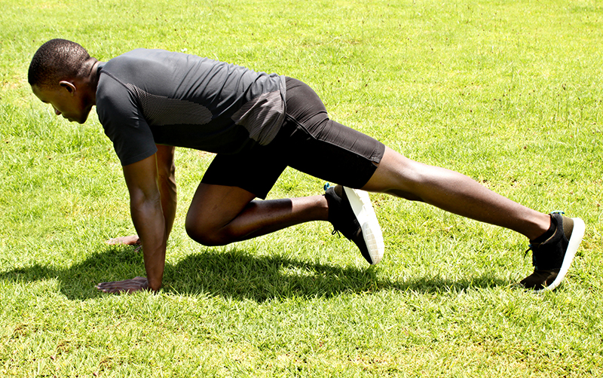

**EXERCISE #2- STAR JUMPS- Stand tall with your arms at your sides. Push your legs out like you are doing a jumping jack and jump at the same time! You will look like a star! Try 10 in a row!**

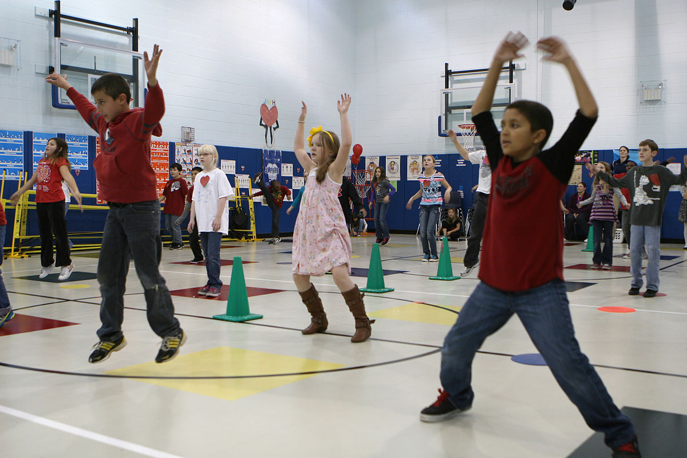

**EXERCISE #3- WINDMILLS- Spread legs apart and place arms up and to the side (see picture below). Try to touch your right hand to your left foot while keeping your arms up and to the side and then come back to the ready position. Try to touch your left hand to your right foot and come up to ready position. Try 10 in a row!**

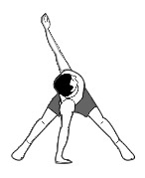

**\*AFTER COMPLETING THE 3 NEW EXERCISES ON 2 DIFFERENT DAYS THIS WEEK, PLEASE PARTICIPATE IN AN ACTIVITY OF YOUR CHOICE ON A DIFFERENT DAY FOR 20 MINUTES THAT RAISES YOUR HEART RATE! MAKE SURE YOU ARE WITH AN ADULT.**

**Hope you had fun trying these new exercises and choosing your own fun activity to do that raises your heart rate!. If you can send me a quick email and let me know how you did!**

[**MillerA@dvsd.org**](mailto:MillerA@dvsd.org)

**Talk to you soon,**

**Mrs. Miller 😊**